How to Help Your Clients Understand Their Window of Tolerance [Infographic]
103 Comments
Clients are best able to cope with stressors and triggers when they can manage the resulting emotions.
So how can we help clients who struggle to manage the anxiety, anger, and pain brought on by everyday stressors?
In situations like this, psychoeducation can be one of our best tools – and one helpful concept is “the window of tolerance.”
The window of tolerance is a concept originally developed by Dr. Dan Siegel, MD to describe the optimal zone of “arousal” for a person to function in everyday life. When a person is operating within this zone or window, they can effectively manage and cope with their emotions.
For clients who have experienced trauma, it is often difficult to regulate emotions and the zone of arousal where they can function effectively becomes quite narrow.
When a client is traumatized, it can be especially difficult for them to stay grounded in the present because the past is more vivid and intrusive. Someone constantly living in their past trauma is primed to detect threat — and enter into that state of defense. That means they generally have a very narrow window of tolerance.
The stress of a traumatic memory or trigger may cause them to be pushed out of their window of tolerance. Even seemingly minor stressors can cause a client to dissociate, get angry, or feel anxious – leading to states of hyperarousal or hypoarousal.
And this can make it difficult for clients to make progress in therapeutic sessions.
We created this infographic as a tool you can share with your clients. It can help you explain what’s going on when they’re feeling dysregulated.
Click the image to enlarge
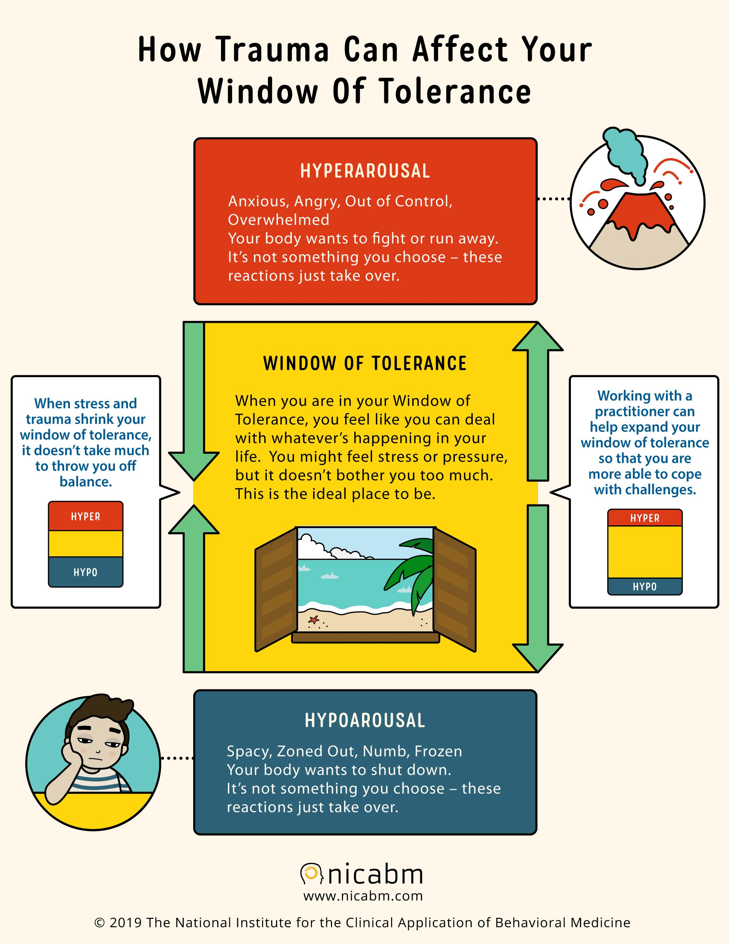
If you’d like to print a copy for yourself, just click here: Color or Print-friendly
(Please be sure to include the copyright information. We put a lot of work into creating these resources for you. Thanks!)
You may already know these concepts well, but for a quick review . . .

What is Hyperarousal?
Hyperarousal is also known as the “fight, flight, or freeze response” and is a heightened state of activation/energy. It is when a client’s nervous system suddenly kicks into high alert, even when danger might not be present. A client may not feel in control over their actions when they enter this state. It can often be triggered by perceived threat, traumatic memories, or specific emotions. It is also one of the primary symptoms of post-traumatic stress disorder (PTSD).
Hyperarousal Symptoms:
- Angry outbursts
- Fear
- Anxiety
- Emotional overwhelm
- Panic
- Hypervigilance
- Tight muscles
- “Deer in the headlights” freeze
Often, clients who experience hyperarousal are stuck “on” which can make it difficult to form healthy sleeping habits, manage emotions, and concentrate effectively. Physically, their body may seem tense and on the brink of explosion, which can eventually result in angry outbursts and hostility.

What is Hypoarousal?
Hypoarousal is also known as the “shutdown” or “collapse” response. Like hyperarousal, it can often be triggered by feeling threatened, recounting traumatic memories, or feeling emotions associated with past trauma. Even a perceived threat can be enough to send a client into shutdown or even dissociation.
Hypoarousal Symptoms:
- Depression
- Numbness
- Emptiness
- Flaccid body
- Blank stare
- Inability to speak
- Dissociation
Hypoarousal is when a client has too little arousal as the result of an overloaded parasympathetic nervous system. It can impact a client’s sleep and eating habits, leaving them feeling emotionally numb, socially withdrawn, and finding it difficult to express themselves.

How to Help a Client Come Back into Their Window of Tolerance
There are many strategies for helping a client come back into their window of tolerance when they feel dysregulated. Depending on whether a client is experiencing hypo or hyperarousal, you will want to orient your interventions to suit the client’s needs.

Coming back from Hypoarousal:
It’s important to keep in mind that our nervous systems often take cues from one another. When working with a hypoaroused client, some simple ways to signal an increase in energy in the room include:
- Increasing vocal prosody
- Using engaged posture
- Utilizing a certain amount of joking or irreverence
- Physical movement, such as standing up or switching chairs
Other useful strategies to help a client shift out of a shutdown or dissociative state include:

Ask your client to describe three things in full detail
You can ask your client, “What are three things that you like to look at in my office?” This activity can help to anchor the client. It helps them connect back to the present moment and their relationship with the practitioner.

Using breath work to calm the nervous system
If you’re seeing that your client’s breathing is getting dysregulated, you can work on re-regulating breathing together with slow exhales.

Use a cognitive technique of scaling (i.e., from zero to 10 . . .) to help clients learn to gauge their level of hyper/hypoarousal.
You may ask your client to scale their level of freeze, dissociation, etc. This can help them learn to better gauge the sensations they are feeling.

Orienting client to present time, present place by explicitly labeling cues of safety: “You’re in my office. It’s <date>, You’re with me, You’re safe.”
Repeating these types of grounding exercises can help elicit feelings of safety.
For more resources on working with the freeze response you can take a look here:
Working with the Freeze Response in the Treatment of Trauma with Stephen Porges, PhD
When a Client Is Stuck in the Freeze Response with Peter Levine, PhD
How to Help a Client Come Back from Freezing in a Session with Bethany Brand, PhD

Coming back from Hyperarousal:
When working with trauma in a session, there can be many perceived threats for clients that may cause them to brace up – or perhaps start to freeze up during the session.
When a client begins to shift into a freeze response, their muscles lock in against each other and that energy becomes stuck within them. You often begin to see them pulling inward and “becoming small.”
To work with this, it can help to have your client access that locked-in energy, one small amount at a time. The key here is to titrate therapy and move at a slow, gentle pace. This can be key to help keep a client from becoming overwhelmed in that moment.
On the other hand, a client’s energy might burst before you can help them manage it in a healthy way. In this case, they may find trouble finding a sense of containment. They may experience fear, panic, or a flood of emotions. Here, certain body-oriented methods may be helpful in re-centering them into the window of tolerance.
Effective strategies to help clients manage hyperarousal:
- Using diaphragmatic breathing
- Drinking from a straw
- Meditation
- Yoga techniques
- Healthy strategies for releasing anger
If a client is experiencing anxiety from hyperarousal, we created a tool based on the work of Shelly Harrell, PhD for practitioners to share with their clients. It breaks down four key strategies to manage anxiety and reduce residual stress.

How to Help Clients Manage Their Window of Tolerance
We want to help clients broaden their window of tolerance and increase their capacity to experience emotions (even intense ones) without becoming dysregulated. This first starts by helping clients recognize when they are experiencing emotions outside their tolerable zone – and gauging how it makes them feel and how it impacts their body.
Clients can begin to manage their window of tolerance by:
- Recognizing their window of tolerance and increasing their awareness of symptoms
- Widening their window of tolerable emotions
- Learn techniques for re-regulating when experiencing hypoarousal or hyperarousal

We’ve already taken a look at recognizing when a client is outside their window of tolerance (and how that can be expressed by hypoarousal and hyperarousal). But how can we help clients widen their window of tolerance?
Certain strategies such as body-based approaches and exposure-based strategies can be effective in helping clients widen their tolerance for intense emotions.
It can also be effective in helping clients reduce any shame they might feel from being easily dysregulated. This will open up their ability to explore and listen to their experiences without shame disrupting the healing process. Compassion-focused strategies can be effective in promoting self-compassion and self-acceptance when working to build resilience.
Part of equipping clients to take on potentially triggering experiences is giving them strategies to tolerate discomfort and distress.
If you would like to find out how the top experts in the field (like Peter Levine, PhD; Janina Fisher, PhD; Ron Siegel, PsyD, Shelly Harrell, PhD; and more) help clients build a greater tolerance for emotional distress, you can click here.

Helping Clients Stay Regulated Outside of Sessions:
We’ve taken a look at strategies for helping clients re-regulate and come back into their window of tolerance when in a session. But what about when they are not in your office? Clients will not always have you as resource, so it is important to equip clients with strategies they can use on their own.
- Breathwork – Using the mindful experience of breathing as an anchor to the body and the present.

- Guided Imagery – To start, in place of breathwork, a client might imagine themselves on a swing, paying attention to the internal feelings of the movement. The rocking motion of the swing actually brings the breath online in a different way, helping to circumvent certain triggers.

- Positive Containment Imagery – An example of positive containment imagery might be to have a client imagine a chest, or whatever their choice of container might be. Then, they can imagine arranging the intrusive thoughts or images in that chest or container, and locking it securely until they’re ready to process them more fully.

- Safe Place or Sacred Space Imagery – Finally, there is safe place or sacred space imagery. They can base this place on any real, fictional, or imaginary location where they feel calm or content, and can design it at will. By giving the client an image where they have complete control, it can reduce a sense of helplessness or uncertainty in life.

For more strategies you can use to help clients who’ve experienced trauma, be sure to check out the Treating Trauma Master Series.
You’ll get insights from Bessel van der Kolk, MD; Dan Siegel, MD; Pat Ogden, PhD; Stephen Porges, PhD; Peter Levine, PhD; Allan Schore, PhD; and Ruth Lanius, MD, PhD.
Now we’d like to hear from you.
How have you worked with the window of tolerance with your clients? Could this help you in your work? Please leave a comment below and share your experience.
Printed 02/11/2021 from:
How to Help Your Clients Understand Their Window of Tolerance (nicabm.com)
https://www.nicabm.com/trauma-how-to-help-your-clients-understand-their-window-of-tolerance/

